Genome-wide characterization, expression profile analysis of WRKY family genes in Santalum album and functional identification of their role in abiotic stress

Haifeng Yan#^{1,2}, Mingzhi Li#³, Yuping Xiong#¹, Yueya Zhang¹, Hanzhi Liang¹, Yuan Li¹, Xinhua Zhang¹, Meiyun Niu¹, Beiyi Guo¹, Jaime A. Teixeira da Silva^{4*}, Guohua Ma^{1*}

¹ Guangdong Provincial Key Laboratory of Applied Botany, South China Botanical Garden, the Chinese Academy of Sciences, Guangzhou, 510650, China
² Cash Crop Institute of Guangxi Academy of Agricultural Sciences, Nanning, 530007, China
³ Biodata Biotechnology Co. Ltd, Heifei , 230031, China.
⁴ P.O. Box 7, Miki-cho Post Office, Miki-cho, Ikenobe 3011-2, Kagawa-ken, 761-0799, Japan
*Co-corresponding authors: jaimetex@yahoo.com; magh@scib.ac.cn
#These authors contributed equally to this work

Additional files:
Additional file 1: Table S1. The GenBank accession numbers of 64 SaWRKY genes.
Gene name | GenBank  accession number | Gene name | GenBank  accession number
SaWRKY1 | MG655189 | SaWRKY33 | MN335843
SaWRKY2 | MN335812 | SaWRKY34 | MN335844
SaWRKY3 | MN335813 | SaWRKY35 | MN335845
SaWRKY4 | MN335814 | SaWRKY36 | MN335846
SaWRKY5 | MN335815 | SaWRKY37 | MN335847
SaWRKY6 | MN335816 | SaWRKY38 | MN335848
SaWRKY7 | MN335817 | SaWRKY39 | MN335849
SaWRKY8 | MN335818 | SaWRKY40 | MN335850
SaWRKY9 | MN335819 | SaWRKY41 | MN335851
SaWRKY10 | MN335820 | SaWRKY42 | MN335852
SaWRKY11 | MN335821 | SaWRKY43 | MN335853
SaWRKY12 | MN335822 | SaWRKY44 | MN335854
SaWRKY13 | MN335823 | SaWRKY45 | MN335855
SaWRKY14 | MN335824 | SaWRKY46 | MN335856
SaWRKY15 | MN335825 | SaWRKY47 | MN335857
SaWRKY16 | MN335826 | SaWRKY48 | MN335858
SaWRKY17 | MN335827 | SaWRKY49 | MN335859
SaWRKY18 | MN335828 | SaWRKY50 | MN335860
SaWRKY19 | MN335829 | SaWRKY51 | MN335861
SaWRKY20 | MN335830 | SaWRKY52 | MN335862
SaWRKY21 | MN335831 | SaWRKY53 | MN335863
SaWRKY22 | MN335832 | SaWRKY54 | MN335864
SaWRKY23 | MN335833 | SaWRKY55 | MN335865
SaWRKY24 | MN335834 | SaWRKY56 | MN335866
SaWRKY25 | MN335835 | SaWRKY57 | MN335867
SaWRKY26 | MN335836 | SaWRKY58 | MN335868
SaWRKY27 | MN335837 | SaWRKY59 | MN335869
SaWRKY28 | MN335838 | SaWRKY60 | MN335870
SaWRKY29 | MN335839 | SaWRKY61 | MN335871
SaWRKY30 | MN335840 | SaWRKY62 | MN335872
SaWRKY31 | MN335841 | SaWRKY63 | MN335873
SaWRKY32 | MN335842 | SaWRKY64 | MN335874

Additional file 2: Table S2. The fold change of SaWRKY genes under SA stress in callus of S. album calculated from the 2^{−ΔΔCq} value.
Gene name | 3 h |  | 6 h
Gene name | fold change | regulation | fold change | regulation
SaWRKY1 | 1.605924743 | up | 0.735998567
SaWRKY2 | 0.537153006 |  | 0.525560002
SaWRKY3 | 10.84384601 | up | 6.099365236 | up
SaWRKY4 | 1.071276507 |  | 0.251855662 | down
SaWRKY5 | 0.676674053 |  | 0.351579074 | down
SaWRKY6 | 0.415637521 | down | 0.465859976 | down
SaWRKY7 | 1.319702377 |  | 0.443804223 | down
SaWRKY8 | 0.412266327 | down | 0.162274842 | down
SaWRKY9 | 3.04088964 | up | 1.488013672
SaWRKY10 | 0.397683255 | down | 0.443783296 | down
SaWRKY11 | 1.033420563 |  | 3.342963609 | up
SaWRKY12 | 0.32205096 | down | 0.477520245 | down
SaWRKY13 | 0.096026186 | down | 0.62858255
SaWRKY14 | 0.379213567 | down | 0.355096441 | down
SaWRKY15 | 0.583036999 |  | 1.103301147
SaWRKY16 | 0.645843703 |  | 0.956461588
SaWRKY17 | 0.462819588 | down | 0.768802844
SaWRKY18 | 0.451183923 | down | 0.479444789 | down
SaWRKY20 | 0.807874025 |  | 0.584885002
SaWRKY21 | 0.282121074 | down | 0.294825553 | down
SaWRKY22 | 0.469937325 | down | 0.213779396 | down
SaWRKY23 | 0.490749932 | down | 0.481603494 | down
SaWRKY24 | 0.372378699 | down | 0.995162374
SaWRKY25 | 2.814523464 | up | 2.875247387 | up
SaWRKY26 | 0.320591173 | down | 0.257018879 | down
SaWRKY27 | 0.199890748 | down | 0.10642892 | down
SaWRKY28 | 3.03721197 | up | 0.390261045
SaWRKY29 | 0.821375627 |  | 0.617839039
SaWRKY30 | 0.345408466 | down | 0.30867348 | down
SaWRKY31 | 0.628406119 |  | 0.583638032
SaWRKY32 | 0.666384231 |  | 0.245358206 | down
SaWRKY33 | 0.598759501 |  | 0.327157748 | down
SaWRKY34 | 0.324919617 | down | 0.238440364 | down
SaWRKY35 | 0.854708054 |  | 15.12074866 | up
SaWRKY36 | 0.34060213 | down | 0.161010295 | down
SaWRKY37 | 1.954973564 | up | 6.845455225 | up
SaWRKY38 | 1.646126133 | up | 0.874035174
SaWRKY39 | 0.802272998 |  | 0.747603461
SaWRKY40 | 1.806936124 | up | 1.694738431 | up
SaWRKY41 | 0.81067293 |  | 0.445648261 | down
SaWRKY42 | 0.849917579 |  | 0.482820306 | down
SaWRKY44 | 0.55646015 |  | 0.736717673

Additional file 3: Table S3. The fold change of SaWRKY genes under MeJA stress in callus of S. album calculated from the 2^{−ΔΔCq} value.

Gene name | 3 h |  | 6 h
Gene name | fold change | regulation | fold change | regulation
SaWRKY1 | 1.523806133 | up | 1.243573885
SaWRKY2 | 1.016829011 |  | 1.051604875
SaWRKY3 | 1.202386148 |  | 1.997276182 | up
SaWRKY4 | 7.650994727 | up | 4.510385779 | up
SaWRKY5 | 1.066676806 |  | 1.092140994
SaWRKY6 | 1.280020997 |  | 1.360982414
SaWRKY7 | 2.18101066 | up | 1.025059598
SaWRKY8 | 1.534744776 | up | 1.05618636
SaWRKY9 | 0.869566996 |  | 0.578525604
SaWRKY10 | 0.492975832 | down | 0.621533256
SaWRKY11 | 1.973764737 | up | 0.982515772
SaWRKY12 | 1.124886018 |  | 1.284995227
SaWRKY13 | 0.384743767 | down | 0.456637496 | down
SaWRKY14 | 0.727136672 |  | 0.742497347
SaWRKY15 | 1.307118602 |  | 1.469757594
SaWRKY16 | 1.910763766 | up | 1.256078027
SaWRKY17 | 1.457438912 |  | 1.451419081
SaWRKY18 | 0.789134086 |  | 0.848631782
SaWRKY20 | 1.379357338 |  | 1.084445108
SaWRKY21 | 0.516762202 |  | 0.87556008
SaWRKY22 | 1.219673678 |  | 1.340065204
SaWRKY23 | 1.074212749 |  | 0.521807605
SaWRKY24 | 0.311727391 | down | 0.855498091
SaWRKY25 | 0.436483092 | down | 0.459401352 | down
SaWRKY26 | 2.309527512 | up | 1.799272499 | up
SaWRKY27 | 1.066375061 |  | 0.499563576 | down
SaWRKY28 | 1.140347456 |  | 0.443507138 | down
SaWRKY29 | 2.047877559 | up | 1.182777153
SaWRKY30 | 0.888485079 |  | 1.084359088
SaWRKY31 | 1.035983191 |  | 0.87718525
SaWRKY32 | 1.223856128 |  | 1.249629538
SaWRKY33 | 0.519269451 |  | 0.648834394
SaWRKY34 | 0.992895416 |  | 1.039788876
SaWRKY35 | 1.000891475 |  | 0.872734429
SaWRKY36 | 1.689855066 | up | 1.539139542 | up
SaWRKY37 | 0.483476736 | down | 1.359183086
SaWRKY38 | 1.367902433 |  | 1.957103156 | up
SaWRKY39 | 1.274716561 |  | 1.207453715
SaWRKY40 | 1.46734427 |  | 1.302318118
SaWRKY41 | 1.001116894 |  | 1.329646892
SaWRKY42 | 1.660090862 | up | 1.763141929 | up
SaWRKY44 | 0.876206427 |  | 0.932704887

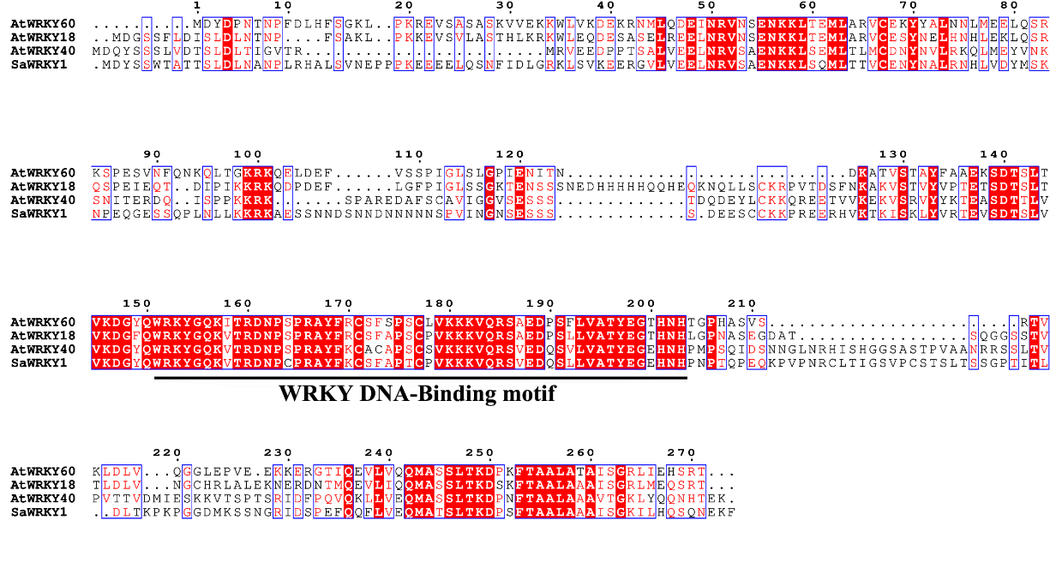
Additional file 4: Figure S1. Multiple sequence alignment among SaWRKY1, AtWRKY40, AtWRKY18, and AtWRKY60.

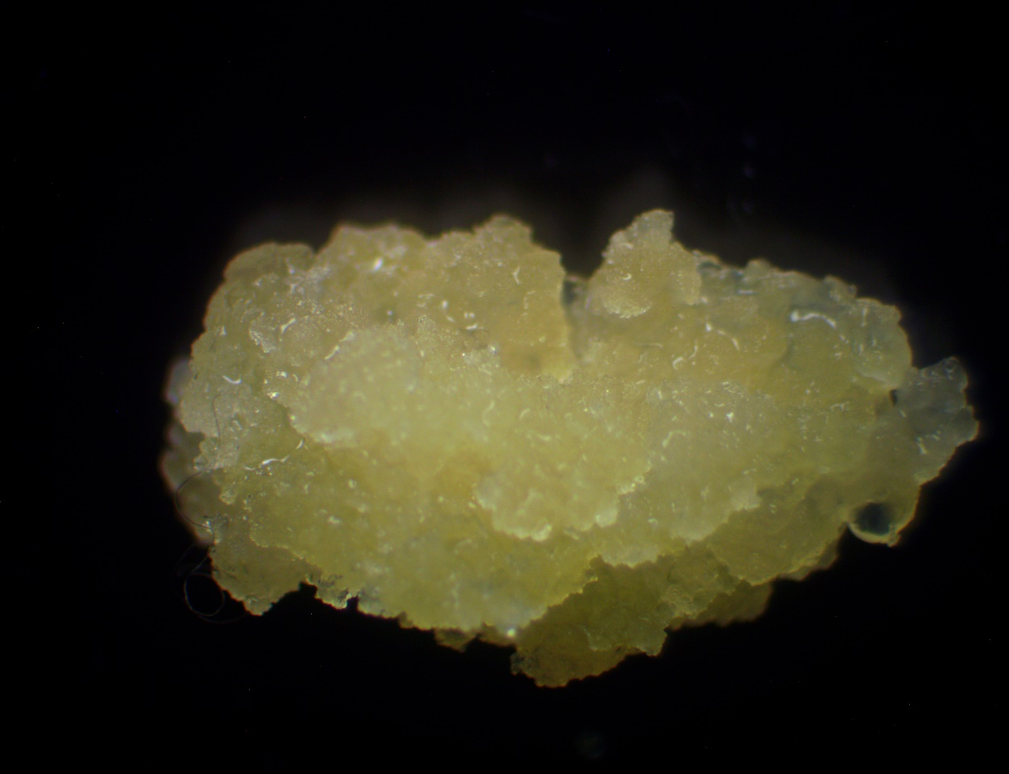
Additional file 5: Figure S2. Callus used in this study.

Additional file 6: Table S4. Primers used for RT-qPCR.

Primer name | Primer sequence | Primer name | Primer sequence
SaWRKY1F | 5′-TGAGAGCAGCAACAACGATAG-3′ | SaWRKY1R | 5′-CGTTCTTCCCTTGGCTTCTT-3′
SaWRKY2F | 5′-GCCTCATCCGCTCATCATAATA-3′ | SaWRKY2R | 5′-CTCCACCTATAGCCATCATCAAG-3′
SaWRKY3F | 5′-CCGCCAAAGAGAGATCACAA-3′ | SaWRKY3R | 5′-CATTCTCCGTGCCGCTATTA-3′
SaWRKY4F | 5′-GAAAGGGAACAAGCCGAAGA-3′ | SaWRKY4R | 5′-ACCTGTATCCATCCTCCAGAT-3′
SaWRKY5F | 5′-TAGAGAGCAAAGGAGGTCAGA-3′ | SaWRKY5R | 5′-GGGAAGGTGCACTTGTAGTAA-3′
SaWRKY6F | 5′-ACGAAGAGACGGACGTATGA-3′ | SaWRKY6R | 5′-CAACGCTCAACAGAGGAGAA-3′
SaWRKY7F | 5′-TCATGAATCGGGTCCCTTTG-3′ | SaWRKY7R | 5′-TCCAGCGAGAAATCCAATCC-3′
SaWRKY8F | 5′-GAGAAGGAACGGCTGATGTTAT-3′ | SaWRKY8R | 5′-GCTCAGGGCTCTTACTTTGTT-3′
SaWRKY9F | 5′-CCCACCTTATCTTCAACGAAGT-3′ | SaWRKY9R | 5′-AGCTGAGGAGGATGGAGTTA-3′
SaWRKY10F | 5′-GAGGAGGAAGAACTGGAATCAG-3′ | SaWRKY10R | 5′-GAGCTTGGAGAGATCGGTAATC-3′
SaWRKY11F | 5′-GCTCAGTCATGTAACCGACAA-3′ | SaWRKY11R | 5′-CCAAGGCGAAGATCCTCAAA-3′
SaWRKY12F | 5′-CTAGTGCTGGATGCTCTGTTAG-3′ | SaWRKY12R | 5′-ATTGTGCTTTCCCTCGTATGT-3′
SaWRKY13F | 5′-AGAAGTGCACCGTGAAGAAA-3′ | SaWRKY13R | ATGGACAGTGGTGGTTGTG-3′
SaWRKY14F | 5′-ACCTACGCCTTTGACCATAAC-3′ | SaWRKY14R | 5′-CGGCGATGGACGATGATAC-3′
SaWRKY15F | 5′-GTCCGTGTTATCGTCCTCTTC-3′ | SaWRKY15R | 5′-CTTGGCTTGCTCACTTTGTTAG-3′
SaWRKY16F | 5′-ATTCATCGGGCCGTTTCTC-3′ | SaWRKY16R | CTTCTTCTTCTCCGAGGGTTTC-3′
SaWRKY17F | 5′-ACCCGAGACGATAAGAAGGA-3′ | SaWRKY17R | 5′-ATTGGTCGCTACTGGTATTGG-3′
SaWRKY18F | 5′-GGTTATGATGGCGAAGGAGATG-3′ | SaWRKY18R | 5′-ACTACTCTGGGTTCTCGTATGG-3′
SaWRKY20F | 5′-AGAGGAAGAGGAAGAGGAAGAG-3′ | SaWRKY20R | 5′-CCGCCGTTAGGGTTTGTAAT-3′
SaWRKY21F | 5′-GGGTCGGTTTACGATGAACT-3′ | SaWRKY21R | 5′-GGAGGAGGAAGGCATGTTATT-3′
SaWRKY22F | 5′-TGGGCAGAAGCCAATCAA-3′ | SaWRKY22R | 5′-GGTCTTCCAAGCATCTCTCTAC-3′
SaWRKY23F | 5′-ATCCACCACTTGCTCCAATC-3′ | SaWRKY23R | 5′-CGGGCACTTCTACTCTTGTTAG-3′
SaWRKY24F | 5′-TCCACCCTCAGCACTTAAAC-3′ | SaWRKY24R | 5′-CTCTTCTCTTACCTCACCCATTT-3′
SaWRKY25F | 5′-GCCGGGTCAATATCACTCAA-3′ | SaWRKY25R | 5′-TCACCACTTTCTGCCCATAC-3′
SaWRKY26F | 5′-CCCTGATGATGACAGCCTAAT-3′ | SaWRKY26R | 5′-GCTCCATTTGCTCTTCCTTTC-3′
SaWRKY27F | 5′-GGCTACCGATGGCGTAAATA-3′ | SaWRKY27R | 5′-ATGGATCTTCTGAGGACCTTTC-3′
SaWRKY28F | 5′-CAAGTTCCCAAGAGGCTACTAC-3′ | SaWRKY28R | 5′-CCGATAAGTGACCTCGAAGATG-3′
SaWRKY29F | 5′-ACGTGAAGAAGAGAGTGGAGAG-3′ | SaWRKY29R | 5′-ATGGCAACTGGTTGAGGTAAAG-3′
SaWRKY30F | 5′-AAGCTGAGACAGTGAACGATG-3′ | SaWRKY30R | 5′-TCCCGCATTTGAACACCTATAA-3′
SaWRKY31F | 5′-AGAGGCGGAGAGAGTAGTTATAG-3′ | SaWRKY31R | 5′-GTTGGAGGGTGATGCAGTAA-3′
SaWRKY32F | 5′-GAGGCGAGAGTAGCGTTTATG-3′ | SaWRKY32R | 5′-GCAGTGGTGCAACGATAGTA-3′
SaWRKY33F | 5′-TTCTTCGCCCACTTGTTCTAC-3′ | SaWRKY33R | 5′-GGAGCCCATAATCGCTCAAA-3′
SaWRKY34F | 5′-CCAAATCCAAATGCCTCCAATAG-3′ | SaWRKY34R | 5′-GGTAATCCTGAACCAGACTGAAA-3′
SaWRKY35F | 5′-CCATGTCCACGAGCCTATTATC-3′ | SaWRKY35R | 5′-GGTGGTTATGTGTGCCTTCA-3′
SaWRKY36F | 5′-GCGGAAGCAAGACTCTCATAA-3′ | SaWRKY36R | 5′-CAGCGGTATCCATCATTCACTAT-3′
SaWRKY37F | 5′-CTTCGGAGGAGCTTTCTGATT-3′ | SaWRKY37R | 5′-CACGGTGGATAGAGCATTCTT-3′
SaWRKY38F | 5′-AGTGAGGAAGTGGCTGATAATG-3′ | SaWRKY38R | 5′-GCTGGCTCTGAAACCCTATT-3′
SaWRKY39F | 5′-AAGGTTGAGCGTTCTCTTGAT-3′ | SaWRKY39R | 5′-CTACCATCTCTTGTTGGCTTACT-3′
SaWRKY40F | 5′-GGTGCGAGTTGGATGTGAATA-3′ | SaWRKY40R | 5′-CTCGTTTCCCTCGTTTCTCTTC-3′
SaWRKY41F | 5′-GCTGTGCTCACGACTTATGA-3′ | SaWRKY41R | 5′-TGGCGGTCTGTTTAGTGTATG-3′
SaWRKY42F | 5′-GTCATGGGAGAGTCAGAAAGATG-3′ | SaWRKY42R | 5′-GGAACCGCAAGGGATTAGTT-3′
SaWRKY44F | 5′-GTGGAACGCTCTTATGATGGA-3′ | SaWRKY44R | 5′-GGCGTCTAGGTTGAGGTTTAG-3′
SaactinF | 5′- GGATCCACGAGACTACCTACA -3′ | SaactinR | 5′- GAGCCACACTGAGCACAATA-3′
Atactin2F | 5′- CAGAAGGATGCATATGTTGGTG -3′ | Atactin2R | 5′- TGTAGAAAGTGTGATGCCAGAT -3′

Additional file 7: Method S1.
Total RNA was extracted from the leaves of 7-year-old S. album trees using Eastep® Super Total RNA Extraction kit (Promega, Shanghai, China) according to the manufacturer’s instructions. One µg of total RNA was used to synthesize first strand cDNAs for 3′ or 5′ end amplification with the SMARTer RACE cDNA Amplification Kit (Clontech Laboratories Inc., CA, USA) in 20 µL volume. The two specific primers were designed for completing the SaWRKY1 3′ end (F1: 5′-ACCCTACTCAGCCCGA GCAGAA-3′; F2: 5′-GGTGGAACAGATGGCTACC
TCA-3′) and 5′ end (F1: 5′- GTTTCTTGTTTTCGGCACTCAC-3′; F2: 5′-CGTGG CGGAGAGGGTTCG-3′) with nested PCR. PCR products were purified using the Gel Extraction Kit (Dongsheng Biotech, Guangzhou, China). Purified fragments were then cloned into pMD-18-T vector (Takara, Dalian, China) and sequenced at the Beijing Genomics Institute (BGI, Shenzhen, China). After sequence comparison, the full open-reading frame of SaWRKY1 was amplified using gene-specific primers (F: 5′-ATGGATTAC TCTTCTTGGACGGC-3′; R: 5′-TCAA AATTTTTCATTTTGACTTT-3′) by RT-PCR.

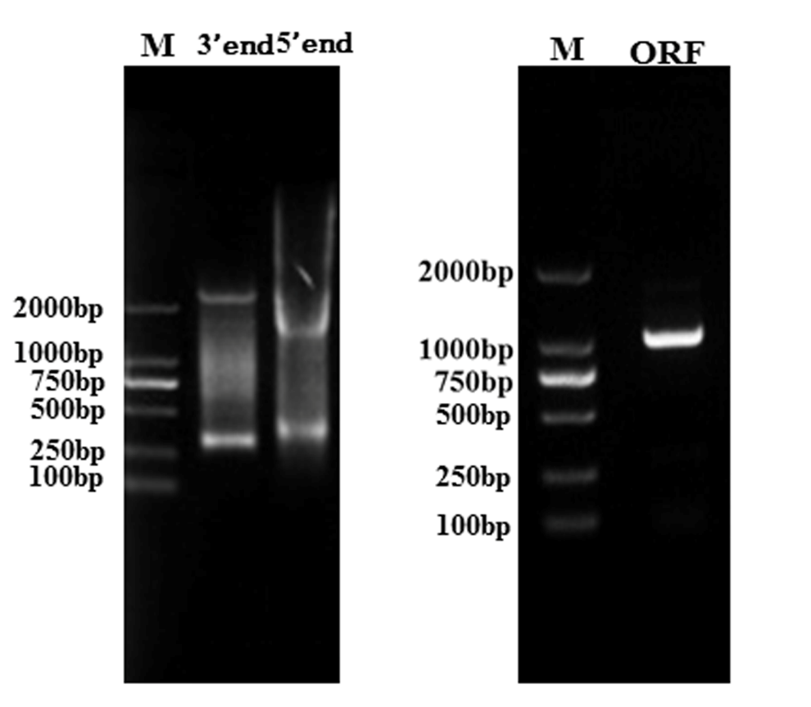
Additional file 8: Figure S3. Amplification of 3′ and 5′ end, as well as the ORF, of SaWRKY1.

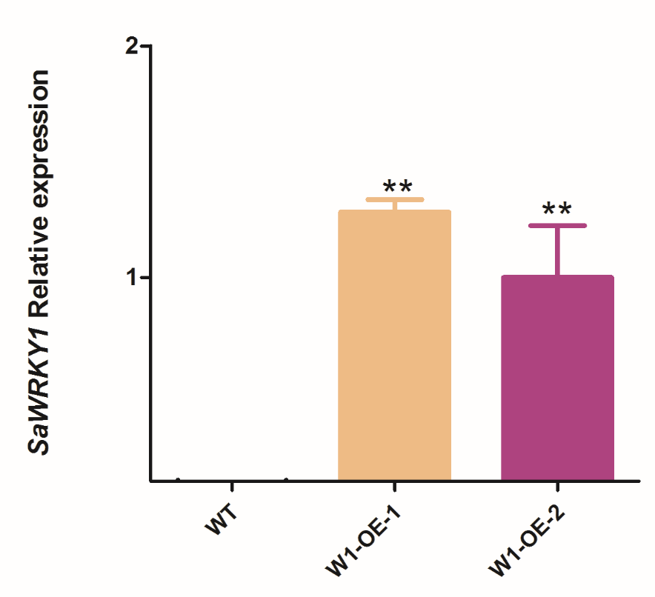
Additional file 9: Figure S4. RT-qPCR analysis of SaWRKY1 gene expression in wild type (WT) and transgenic Arabidopsis. Values shown are the means of three independent biological replicates ± SE. Asterisk indicates significance at P<0.01 between WT and transgenic lines using Duncan’s multiple range test. Atactin2 (AT3G18780) was used as the internal reference gene.

